Deerlake Supply Lists

2020-2021

**6th Grade Supplies:**

2 – 2” Binder in any color

4 sets of 5 tab tabbed dividers

Colored pencils – 12 count

2 Black Dry erase markers

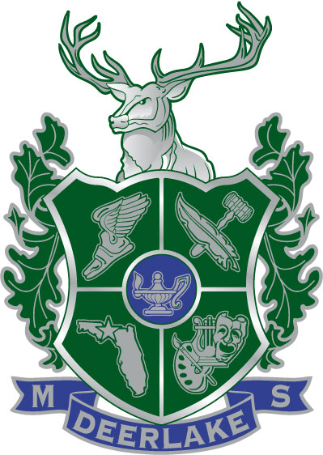2 Highlighters

2 Each Stick Pens – blue, black & red

2 Packages (1 Dozen) #2 Pencils

Index Cards (several packs, any size)

Notebook paper/Graph paper

Cap erasers

2 Washable Glue sticks

2 Sharpies – Permanent Marker

1 Pencil & Crayon Sharpener

1 Composition Notebooks (Notebook paper)

1 Graph Paper Hard Bound Composition Notebook

**7th Grade Supplies:**

Notebook Paper

#2 Pencils

Blue or Black Pens **and** Red pens

Red Pens

Highlighters

Colored pencils

Index cards (several packs any size)

Graph paper

Tabbed dividers (quantity depends on individual teacher)

Spiral Notebook (Lang. Arts)

TI – 30 Xa calculator

Headphones/earbuds

Binders and dividers will be necessary, but students may want to wait and decide on the type and quantity that best meets their needs once classes have begun.

**8th Grade Supplies:**

3 Ring Binder/Tabbed Dividers

Notebook Paper/Graph Paper

Spiral Notebook (100 pages)

Blue, Black and Red Pens/#2 Pencils

Calculator (TI30-Xa)

Highlighters

Index Cards

Colored pencils – 12 count

**Special Notes:**

Protractor & compass for students in Geometry

Hard bound composition notebook for Fantasy Literature and Biology

* **Individual teachers and elective classes may require additional supplies.**
* **Headphones/Earbuds for all grades**